MSTS SHR EMD-STD-1 CAB
By Charlie Sibaja
(charliesibajamsts@yahoo.com)

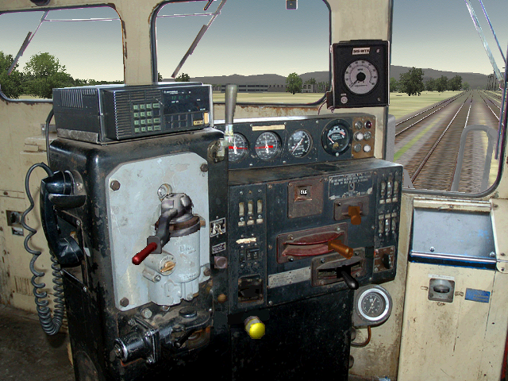

First: You might want to print this document.

INTRODUCTION
This is a photorealistic cab for the EMD Engines like the GP9, GP10, GP11, GP15, GP18, GP20, GP30, GP35, GP38, GP40, SD9, SD24, SD35, SD40, SD45 and many others, not the dash-2.
Includes High Resolution graphics, night views and diverse versions for:
ARR, ATSF, BN, BNSF, BO, Chessie, CN, CP, CNW, CR, CRR, CSX, DRGW, FNM, FXE, GN, GTW, IC, ICG, LN, KCS, MILW, MKT, MP, MRL, NS, NW, RI, SBD, SOO, SOU, SP, SPSF, UP and USAX.
It has a wide vision angle for a better realistic experience like the real life, 195 diferents modes of cabviews.

The cab used a variation of “combined power”. The combined power used a Selector Switch to place the engine into power mode or dynamic brake mode. Even there is no key in MSTS to actuate this feature, the ace files was modificated to simulate the operation of this switch. I believe the effect is there. The use of the “A” and “D” keys (as used in the MSTS dash-9) simulates the combined power and the effect of the Selector Switch. Combined control original concept by Dwight Mitchell and Ken Powers.

Credits:

All ace are my own creations except for the Right and left view original from TrainArtisan (reworked for me) and some controls and display indicators.
Front Photo by James Gardiner.
Original Read me instructions by Dwight Mitchell.
Combined control original concept by Dwight Mitchell and Ken Powers.
Cabview by Charlie Sibaja.

INSTALLATION (You must have knowledge of how to modify the eng file)

- Always backup all files before you edit them!

2. Unzip this file to the drive where MSTS is located (normally drive C:). This will create the directory
x:\Program Files\Microsoft Games\Train Simulator\TRAINS\TRAINSET\SHR.CABS\EMD-STD-1-CAB
Where x:\ is the drive where MSTS is located

- In the sub-folder “ALIAS” of this file are 183 cvf files

- Choose one of the files in step 3 and copy it into the cabview folder of the engine you want to use this cabview in. If your engine does not have a Cabview folder then create one and then copy the file into this folder.

- Now the tricky part. Open your eng file with a Unicode text editor (Wordpad for example) and search for CabView:

NumWheels ( 1 )
MaxTemperature ( 120 )
MaxOilPressure ( 90 )
CabView ( GP38.cvf )
MaxDieselLevel ( 3600gal )
DieselUsedPerHourAtMaxPower ( 60gal )
DieselUsedPerHourAtIdle ( 10gal )

Replace the wording GP38.cvf with the name of the file you used in step 3.

6. Look for the following lines: (Skip this step if you are using a Non-Dynamic brake engine and proceed to step 7)

Brake_Dynamic ( 0 1 0.025 0
NumNotches ( 1
Notch ( 0 1 Dummy )
)
)
Combined_Control ( 0 1 0.5 0.5 throttle dynamic )
DirControl ( -1 0 1 1 )
BellToggle( 0 1 0 )
AWS ( 0 1 0 )

Add the line highlighted in BLUE

SAVE THIS FILE

HOW to USE:

Where throttle and dynamic brake handles are separate entities, it is well known that the throttle uses the A & D keys for control and the dynamic brake handle uses the period and comma keys. With the combined power control there is a slightly different concept.
When the Sim starts, it will be noted that the throttle is in the 'IDLE' position. All power settings are made using the A & D keys as usual. When it is determined that dynamic braking is required, the throttle should be decreased to the 'IDLE' position. Then press the A key again. The throttle handle will not move but 'SET' will appear in the window. At this point, allow 10 seconds for the dynamic brake circuitry to be 'set-up'. If the brake is advanced before sufficient time has elapsed, a warning will sound and nothing will happen. When the brake is ready, it may be advanced a notch at a time using the A key. To reduce braking effort, use the D key. To return to power settings, reduce the brake settings back to 'SET'. Pressing the D key again will advance the window back to 'IDLE'.
During dynamic braking, the sounds of the engine will change relative to the setting in both the internal (cab) and external (eng) views. Reverse current readings will also be displayed on the load meter.
There are a few tutorials on the theory and use of dynamic braking floating around.

The real cab.

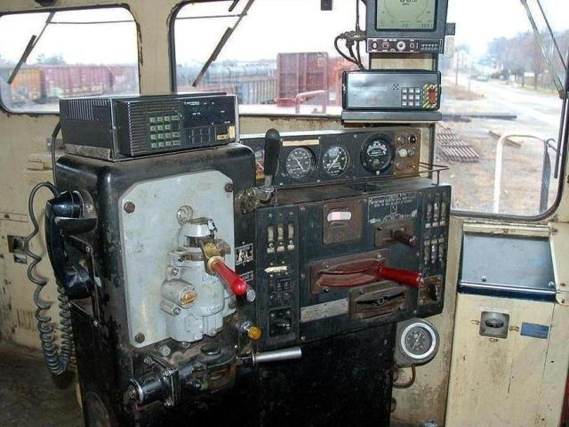
Photo by James Gardiner.

